Measure in power BI

* Measures are used to calculate aggregates, such as the sum or average of a column.
* A measure is a formula that is evaluated in the context in which it is used.

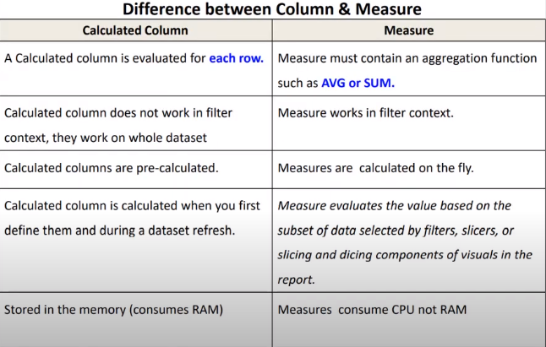Before learning about the measures , let us understand the difference between column and measures

When to use a Measure , and when to use Calculated Column

* Is the calculation row by row ?
* Or it is an aggregation ?
* Is it going to be affected by filter criteria in the report ?